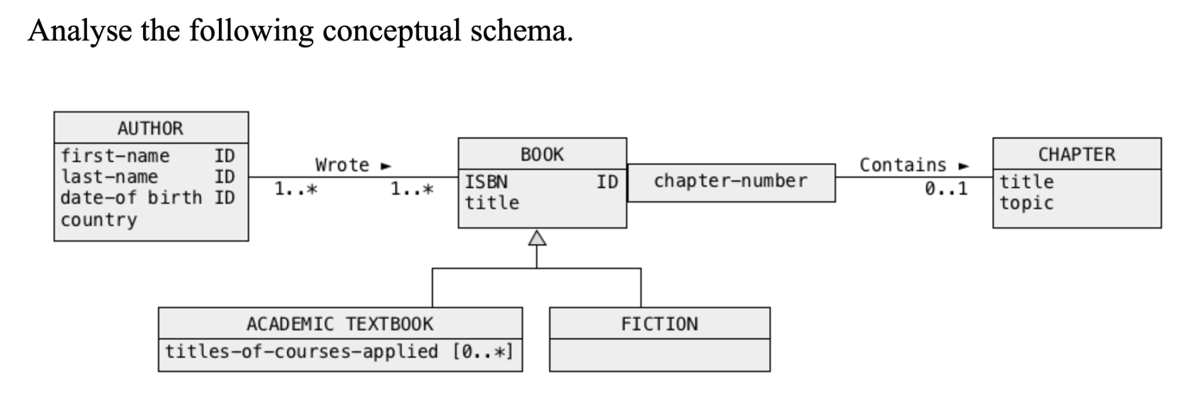**Solution1**

Based on the information provided, here's a textual representation of a UML Class Diagram:

Classes:

1. **Book**

- Attributes:

- ISBN: String

- title: String

- Relationships:

- is parent class to both AcademicTextbook and Fiction.

- 0...* to Author (indicating many to many relation with Author).

- 0...1 to Chapter (indicating a book can have zero or one chapter, even if it's unusual).

2. **AcademicTextbook**

- Attributes:

- None mentioned explicitly.

- Relationships:

- is a subclass of Book.

3. **Fiction**

- Attributes:

- None mentioned explicitly.

- Relationships:

- is a subclass of Book.

4. **Author**

- Attributes:

- firstName: String

- lastName: String

- dateOfBirth: Date

- country: String

- Relationships:

- 0...* to Book (indicating many to many relation with Book).

5. **Chapter**

- Attributes:

- title: String

- topic: String

- Relationships:

- 0...* to Book (even if it's given as 0...1, which is unusual. In a real-world scenario, it should be 1...*).

Note that the relations between Book and Author indicates that a Book can have multiple Authors and an Author can write multiple Books. The relationship between Book and Chapter is noted as 0...1 but ideally, it should be 1...* or 0...* if a book can exist without chapters.

In our system, books are categorized into academic textbooks and fiction. **Each academic textbook is associated with titles of courses to which they are applied.** Meanwhile, both these categories, academic textbooks and fiction, fall under the broader classification of "book", each having a unique ISBN and title.

Each book might be associated with multiple authors. An author possesses attributes like a first name, last name, date of birth, and country. An author can write several books, and a book can also be co-authored by multiple authors.

Additionally, each book might contain chapters, with each chapter having its own title and topic. However, in our current representation, a book is described to contain 0 to 1 chapters, which seems unusual as typically, a book would consist of multiple chapters.